Characterization and validation of a membrane mimetic with magnetic orienting capabilities and natural phospholipids content

D. Muñoz-Gacitúaa,[1], Matias Monroy-Cárdenasb, R. Araya-Maturanab, B. Weiss-Lópeza

*aLaboratorio de Fisicoquímica Molecular, Facultad de Ciencias, Universidad de Chile, Santiago, Chile bInstituto de Química de Recursos Naturales, Universidad de Talca, Talca, Chile.*

# Abstract

The cellular membrane in a highly complex structure with variable and inhomogeneous composition which makes the direct study of the sole lipid bilayer a very difficult task, this introduces the necessity of membrane mimetics, that is, lipid bilayer structures that behave as close as possible to the cellular membrane. In this article we present a membrane mimetic with a high phospholipid content, the main component in natural lipid membranes, and the capability of orienting itself when exposed to an external magnetic field, this enables it for studies of its dynamics and mobility employing 2H-NMR. We validate its permeability properties as membrane mimetic by reproducing the membrane-permeating ability of Benzocaine, and the inability of Levodopa to do so. We also present a molecular dynamics simulation model of the membrane mimetic, calibrated to reproduce experimental 2H-NMR results.

Ramamoort

cita este

paper como

la primera

bicela

*Keywords:* Membrane mimetic, 2H-RMN, Molecular dynamics

# 1. Introduction

The cell is a highly complex unit present in all living organisms: it constitutes the building block of life. Essentially, consists in a closed domain containing smaller organelles in a highly complex and crowded aqueous solution, all enclosed by a bilayer made of mainly phospholipids and containing fatty acids, sugars, cholesterol and proteins, among others. This bilayer is called cell membrane or cytoplasmic membrane. Membranes itself are very complex molecular organizations with variable and inhomogeneous composition, and its atomic level understanding is a very difficult task. For this reason, the employment of membrane mimetics and models has become common practice.1

Because of their ability to orient spontaneously when exposed to an external magnetic field, bilayered micelles, also called “bicelles”, have been widely used as membrane mimetics, as they allow the use of solution NMR to probe the orientation and dynamics of liposomes and drugs2–4. The bicelle structure was first introduced in the late 70s as a mixture of sodium decyl sulphate and 1-decanol5. Later, in the 1990s, it was discovered that a mixture of DMPC[2] and CHAPSO[3] forms magnetically orientable bilayered micelles6, this composition is suitable to use as a membrane mimetic, as it contains phospholipid in its composition, however should be noted that a single phospholipid does not represent the complexity of the mixture found in natural membranes. Many improvements have been made to this composition over the years, among these improvements, it was found that CHAPSO can be replaced by DHPC[4] which has a structure that resembles more to a natural phospholipid7, it was also found that the addition of cholesterol improves the stability of the bilayer8 and the addition of Triton X-100 detergent improves its magnetic orienting capabilities9. Nowadays, bicelles are considered good membrane mimetics, as they have been successfully employed to predict drug permeability through the membrane10–13, and to elucidate structures for proteins in the transmembrane domain14. The use of bicelles is ideal when the drug-detergent (or protein-detergent) complex is small (<100kDa), as these systems can be studied in solution NMR15–17.

Membrane proteins play a significant role in human pathologies18,19. About 30% of human genes code for membrane proteins20 and they are targeted by more than 50% of drugs21,22. Therefore, most drugs have to cross membrane interfaces to reach their active site, and consequently, the activity of these drugs depends, among other factors, on their ability to perform this task. For this reason, it is important for a membrane mimetic to be able to reproduce permeation of drugs and proteins, as they would on a cellular membrane. As a way of testing permeability of membrane mimetics, we propose the use of Benzocaine and Levodopa, whose penetrating activity (or lack of) has been studied.

Benzocaine is a well-known local anesthetic for topical use. It has been widely employed anesthetizing the oropharynx for trans-esophageal echocardiography, bonchoscopy, esophagogastroduodenoscopy, in cold sores, mouth ulcers, toothache, sore gums and denture ache among others23. Benzocaine has been subject of a significant number of studies, including free energy transfer from water to the interior of different membrane mimetics24–27, estimations about location and orientation in different bilayers and monolayers28–31, interactions with a variety of solvents32–36 and encapsulation in different structures for controlled delivery purposes37–41 among others. All the evidence confirms that Benzocaine is able to cross the interface of membrane mimetics to become incorporated into the hydrophobic bilayer to finally be located at the inner interface.

Contrary to most local anesthetics, Levodopa (or L-DOPA), the precursor of the neurotransmitter dopamine, commonly used in treatment of Parkinson’s disease42, is able to cross membrane interfaces only via active processes43,44. Therefore, in the absence of appropriate specific receptors, Levodopa should remain attached to the outer interface and should not reach the hydrophobic bilayer45.

In this article, we developed a new anionic nematic lyotropic liquid crystal, with bilayer structure, susceptible to be used as membrane mimetic. It is made of sodium dodecyl sulfate (SDS), 1-decanol (DeOH), sodium sulphate (Na2SO4) and a mixture of natural phospholipids extracted from soybean, all dissolved in water. The structure of the mesophase, which spontaneously orients in magnetic fields, was characterized using polarized light microscopy textures and to observe the dynamics of the interface and deeper into the hydrophobic core, 2H-NMR quadrupole splittings from HDO, DeOH-*α*-d2, and SDS-d25 were measured. To test the capability of the new mimetic to reproduce cell membrane behavior, Benzocaine and Levodopa were dissolved in the mesophase solution. According to previous evidence, Benzocaine should spontaneously be incorporated inside the bilayer and become located around the inner interface24, whereas Levodopa should remain attached to the outer interface45. To obtain an atomic detailed characterization of the mimetic dynamics and structure, including information about location, interface crossing dynamics and interactions of Benzocaine and Levodopa with the bilayer components, the spectroscopic measurements were complemented with classical molecular dynamics (MD) simulations.

# 2. Materials and methods

**2.1. Materials.**

The reagents SDS, SDS-d25, sodium sulphate and a phospholipid mixture extracted from soybean were purchased from *Sigma Aldrich*. DeOH, deuterium oxide and HPLC-grade water were purchased from *Merck*. All these reagents were employed without alterations, excepting sodium sulphate which was oven dried 24 hours before used. Deuterated 1-decanol (DeOH-*α*-d2) was synthesized by reducing ethyl decanoate (C12H24O2) with lithium aluminum deuteride (LiAlD4) and purified by vacuum fractional distillation.

**2.2. Sample preparation.**

Samples were prepared by mixing each dry component (SDS, Na2SO4 and phospholipid mixture) in a 5mL centrifuge tube, and then adding DeOH and deuterium enriched water(0*.*5%*vv*D2O), with each component weighted and added in proportion according to Bahamonde’s bicelle46, phospholipid content was added while keeping the rest of the components in proportion. Each sample is then submitted to a rotational mixer at 4rpm for 24 hours at a temperature of 37◦C, and then centrifuged at 6000rpm for 3 minutes.

## 2.3. Nuclear magnetic resonance

All solution 2H-NMR experiments were carried out on a Bruker Avance 400 spectrometer (Universidad de Santiago de Chile, Santiago, Chile) operating at 61*.*422MHz. Spectra were obtained with a *π/*2 pulse length of 22*.*4 µs, an acquisition time of 760ms, an spectral width of 43*.*1kHz and a digital resolution of 1*.*32Hz per point. 256 scans were acquired per spectrum. Spectra were acquired at 37◦C, and a 10 minute preacquisition delay was employed to allow each sample reach thermal equilibrium. Spectra were processed using Bruker TopSpin 4.0 software.

## 2.4. Molecular dynamics

All simulations were performed using the GROMACS-201647 software bundle. A cutoff scheme was used for non-bonding interactions according to each force-field recommendation values, and long range electrostatic interactions were calculated employing the particle mesh Ewald method48. Temperature control was achieved with a modified Berendsen thermostat49 with a time constant of 1*.*0ps, while pressure was equilibrated with a semi-isotropic Berendsen barostat50 with a time constant of 1*.*0ps for both xy-plane and z-axis. Both temperature and pressure were adjusted to 310K and 1bar respectively. Periodic boundary conditions were applied on all three dimensions.

Before each production simulation, a short equilibration run was performed for a duration of 1ns with an integration time-step of 1fs. Afterwards, each production run was calculated to a duration of 40ns with an integration time-step of 2fs. TIP3P water model51,52 was employed on the simulation with CHARMM36 force-field, while SPC/E53 was employed on simulations with Berger and Gromos53A6 force-fields. The same initial configuration was employed to test each force-field, and it was generated using software Packmol54 arranging a bilayer with composition in the same proportion as the membrane mimetic in table 1 to a total of 9613 molecules. The phospholipid mixture was simulated as a mixture of 39% PLPC[5], 26% DLPCe, 24% DLPE[6] and 11% DOPEg. These proportions were chosen in accordance with the composition of the phospholipid mixture employed, as reported by the vendor.

PMF calculations were performed employing the Umbrella Sampling/WHAM method55. The starting configuration of each simulation window employed for the PMF calculation was generated from a trajectory of the target molecule pulling away from the center of the bilayer, making a starting point each 1*.*5 Å, up to 4*.*5nm making a total of 30 simulation windows. Each simulation window was calculated with the same parameters as the calibrated model shown ahead, up to a total of 20ns on each window, with a weak harmonic force with constant 240kJmol−1nm−2 applied on the bilayer in order to maintain its shape and position during the course of each simulation window.

# 3. Results and discussion

## 3.1. Preparation of the membrane mimetic

In order to achieve a membrane mimetic that behaves as similar as possible to the actual cellular membrane, it is necessary to maximize its phospholipid concentration. This is important considering that multiple researchers have concluded that there are specific interactions between phosphate from the multiple phospholipids and certain amino-acids that modify the membrane permeability where this interaction occurs56,57. Also, the membrane mimetic must orient itself in presence of an external magnetic field. This is so the deuterated probes in the mimetic can produce a *quadrupole splitting* in a solution 2H-RMN spectrum, which will be used to assess the mobility, location and average orientation of deuterium labeled components. Both these requirements were fulfilled by employing the membrane mimetic studied by Bahamonde *et al*46 as starting point, then introducing and maximizing the concentration of phospholipid onto this composition. The maximization was performed in two steps. In a first step, a batch of membrane mimetics was prepared, each one with an increasing amount of phospholipid from 0% up to 30% (see figure 1), 2H-RMN spectra from HDO and DeOH-*α*-*d*2; and polarized light microscopy pictures were taken to each prepared membrane mimetic. From these, the composition with 22% of phospholipid was chosen to continue with the next maximization step, as this was the composition with highest phospholipid content that retained a 2H-NMR spectrum characteristic of a bilayered nematic phase.

During this step of maximization, we noticed a phase transition upon reaching 8% of phospholipid content, this phase transition was also evidenced by polarized light microscopy (see figure 2) where a transition from a *Schlieren* pattern (fig. 2a) to an *oily streak* pattern (fig. 2b) was observed. A similar transition has been observed while studying cationic lipid based bicelles58, where the transition was attributed to a change from a monoaxial disc-shaped bicelles to a biaxial elongated bicelles. We believe a similar transition occurs in our case, considering that the oriented bilayer structure is kept, as it is a necessary condition to observe quadrupolar splittings in 2H-RMN.

A second maximization step was performed by reducing the amount of SDS used to prepare each mimetic and subsequently adding phospholipid until a nematic phase was no longer obtained. The results from the membrane mimetic candidates prepared in this step are summarized in figure 3. From these preparations, the composition with the highest phospholipid content that retained a nematic phase was chosen for further experimentation. The exact composition of the membrane mimetic is detailed in table 1

## 3.2. 2H-NMR and Calibration of a computational model

In order to obtain more reliable information from a molecular dynamic simulation, it has to be calibrated to reproduce known experimental results, which is why we tested multiple force-fields to see which ones reproduce better the mobility of the lipid chains, evidenced by spectral 2H-RMN results. Figure 4 shows

Table 1:

|  |  |
| --- | --- |
| Compound | Content [*ww*%] |
| Sodium dodecyl sulphate | 18.65% |
| Sodium sulphate | 1.55% |
| 1-decanol | 3.92% |
| Phospholipid mixture | 26.76% |
| Water | 49.12% |

the 2H-NMR spectrum of a membrane mimetic prepared according to the composition stated in table 1 and enriched with HDO and SDS-d25. The quadrupolar splitting of each C-D bond depend largely to their order parameter (*SCD*, see equation 1), therefore it makes sense to assign each quadrupolar splitting from the least ordered to the most ordered, resulting in the following assignations: The central, less split doublet arises from the deuterated methyl group (CD3-) capping the tail of each SDS-d25, as the free rotation of this group produces a lower order parameter. The rest of the more split signals correspond to the subsequent deuretated methylenes (-CD2-), with the methylenes closer to the charged sulphate end having a higher quadrupolar splitting, as the strong Coulombic interaction between this charged end and the interface produces a restraining effect on the movement of the particles that are closer to the interface. The adjustment of the simulation relies on the correct reproduction of these quadrupolar splittings of SDS-d25, as they reflect the orientational dynamics of the components of the lipid in the bilayer.

As a first step, three force-fields with different partial charge distributions were tested. These force-fields were chosen due to their ability to reproduce structures of SDS aggregates59.

The tested force-fields were:

* CHARMM3660
* Berger61 with partial charge distribution according to Merz-Kollman method62
* Berger with partial charge distribution according to Gromos53A663 parameters.
* Gromos53A6 with partial charge distribution according to Merz-Kollman method. And
* Gromos53A6 with partial charge distribution according to its own parameters.

From each resulting simulation run, deuterium order parameters (*SCD*) were calculated for the SDS aliphatic chain, which were used to calculate a predicted quadrupolar splitting employing equation (1). These order parameters depend on a coupling constant (*e*2*qQ/h*, 170kHz for aliphatic deuterons64) and the angle (*θ*) between the normal to the bilayer and the applied magnetic field. Software gmx order included in GROMACS was employed to calculate the deuterium order parameter from each simulation.

∆*ν* = 3 *e*2*qQ*(3cos2*θ*−1)*SCD* (1)

4 *h*

These predicted quadrupolar splittings were compared with experimental 2H-NMR results, displayed in figure 5, concluding that employing Gromos53A6 force-field yields results that are closer to experimental ones (see figure 4), obtaining a good correlation on the carbons near the interface but with a small discrepancy towards the interior of the bilayer. This means that the deuterons on the SDS chain are displaying more restricted dynamics than observed in 2H-NMR.

Further improvement was done to the fitting of predicted results by employing two thermostats in the simulation, one governing the bulk solution with a reference temperature of 310K and another governing the bilayer components with a reference temperature of 320K. The reasoning behind this decision was based on the expectation that the increased velocity on the bilayer components would have a further effect on the mobility towards the center on the bilayer rather than in the interface, where Coulombic interactions are stronger and have a restraining effect on the mobility of the bilayer. After this adjustment, the simulation results in predicted quadrupolar splittings in very good agreement with the experimental ones, as shown in figure 6.

## 3.3. Membrane mimetic interface characterization

Polarized light microscopy of the composition achieved (shown in table 1) shows a thread-like pattern, this is characteristic of a lyotropic nematic phase65. Furthermore, considering the magnitude of the measured quadrupolar splittings, and the fact that each deuteron in SDS-d25 yields a single quadrupolar splitting in a solution 2H-NMR (see figure 4), we can conclude that this phase not only has a bilayer like structure, but also orients itself with its bilayer normal perpendicular to the magnetic field

With the same settings as in the calibrated model, a simulation run to a total of 100ns was performed, and in order to characterize the bulk-bilayer interface, charge density profiles were calculated for sodium, sulphate and dodecyl sulphate ions (see figure 7).

These charge density profiles show the dodecyl sulphate’s negative charge peaking 1*.*74nm away from the bilayer center, and the counter-ion sodium peaking 1*.*0 Å further away at 1*.*84nm from the bilayer center due to electrostatic repulsions. The high charge polarization (∼±1*.*5qe*/*nm3) present in this area acts as the main barrier against polar compounds, such as zwitter-ionic Levodopa.

A radial distribution function of water and sodium from sulfur in dodecyl sulfate yields a better picture of the interface structure (see figure 8). As can be seen from the radial distribution functions, a first layer of tightly oriented water molecules envelopes the outer layer of the membrane, with most of the sodium counter-ions locating further away from this water layer, at ∼5 Å from the sulfur. This makes sense if one considers that each sulfur in SDS is bonded by four oxygen atoms, three of which are pointing outwards the bilayer, so the closest atom to sulfur not only has to be positively charged, but also has to be small enough to fit between the oxygen atoms, for this reason is that water hydrogen is found closer to the interface than

sodium. calcular grá

## 3.4. Membrane mimetic validation ficos de dis-

tribución de In order to corroborate that the composition achieved (shown in table 1) behaves as a membrane mimetic, cada lípido we tested the permeation properties of two well known drugs: Benzocaine, that is known to be able to passively cross the cellular membrane; and Levodopa, which is known to be able to cross the cellular membrane only via active mechanisms, therefore it should not be able to permeate a membrane mimetic without specific receptors.

### 3.4.1. Benzocaine control

2H-NMR spectrum was taken from a membrane mimetic sample with 8mg Benzocaine added per gram of mimetic enriched with SDS-d25, and compared to a spectrum of the same mimetic without the anesthetic (figure 9). From this result, it can be seen that the presence of Benzocaine alters the quadrupolar splittings of the SDS aliphatic chain from the first up to the sixth carbon, implying that Benzocaine is mostly residing in this area. Employing the calibrated model stated before, a potential of mean force (PMF) profile was calculated for the process of Benzocaine permeating the membrane (figure 10). From this PMF profile it can be deduced that Benzocaine goes through three steps in order to complete its translocation: First, it integrates spontaneously with the outer leaflet of the bilayer, without mayor interactions with the Stern layer. Secondly, Benzocaine “flip-flops” to the opposite leaflet of the bilayer with a small activation energy (11*.*2kJ). And third and finally, it escapes the bilayer into the bulk at a minor energetic cost (27*.*1kJ), showing that Benzocaine permeation through the membrane mimetic is indeed possible.

This mechanisms is concordant with the spectroscopic results (figure 9). In both results, the most stable position for Benzocaine to be in, is indeed inside the bilayer and closer to the interface.

### 3.4.2. Levodopa control

When studying the effects of adding 7mg of Levodopa per gram of membrane mimetic enriched with SDSd25 the effects are minor to negligible (see figure 9), implying that the Levodopa molecules are unable to enter the bilayer to alter its mobility.

Employing the same method as in Benzocaine, a PMF profile was calculated for the process of Levodopa permeating the membrane mimetic (figure 11). This profile shows that the position of lowest energy for Levodopa to be in, is outside the bilayer, alongside the Stern layer; it also shows that in order to permeate the bilayer, Levodopa requires a rather large activation energy (102*.*4kJmol−1) in order to translocate through the membrane, showing that a passive permeation of Levodopa through the membrane mimetic is actually not possible at physiological temperature, as confirmed by 2H-NMR spectra.

# 4. Conclusions

The inclusion of a natural phospholipid mixture in high concentration, make this membrane mimetic a better model reproducing interactions between small proteins (or peptides) and the bilayer, considering that multiple researchers56,57 have found that there is an specific interaction between arginine and the phosphate from each phospholipid that modify the properties of the membrane where this interaction occurs. Additionally, the low cost of the components of this membrane mimetic, compared to the classic DMPC/CHAPSO bicelle, makes it feasible to perform permeability studies of many drugs in tandem.

Also, the ability to orient itself in an external magnetic field and its sodium dodecyl sulphate content, which is relatively inexpensive in deuterated form, makes this membrane mimetic ideal for studies of dynamics employing solution 2H-NMR.

Furthermore, we present a calibrated simulation model employing molecular dynamics, which as shown with the PMF profiles of Benzocaine and Levodopa, it allows to obtain information about the translocating process that is usually unfeasible to obtain via experimental means.

And finally, having proven that Benzocaine, a local anesthetic that permeates the cellular membrane, is able to translocate through the membrane mimetic proposed in this article; and that Levodopa, an amino-acid that cannot permeate passively the cellular membrane, is unable to do so through the membrane mimetic, we conclude that the membrane mimetic composition we propose has similar permeation properties as a cellular membrane, and thus, validating the proposed composition as an actual membrane mimetic.

**Conflicts of interest**

The authors declare no competing financial interests.

# Acknowledgements

The authors are pleased to acknowledge financial support from FONDECYT-Chile (Grant N◦1190382). D.Muñoz-Gacitúa acknowledges a fellowship from CONICYT (Grant N◦212832). The authors also acknowledge the assistance from the staff and facilities at the National Laboratory for High Performance Computing (NLHPC) at Universidad de Chile.

# References

1. A. N. Bondar, *Introduction: Biomembrane Structure, Dynamics, and Reactions*, 2019.
2. M. Beaugrand, A. A. Arnold, A. Juneau, A. B. Gambaro, D. E. Warschawski, P. T. Williamson and I. Marcotte, *Langmuir*, 2016, **32**, 13244–13251.
3. R. Montecinos, H. Ahumada, R. Araya-Maturana, A. F. Olea and B. E. Weiss-López, *Journal of Colloid and Interface Science*, 2007, **316**, 126–131.
4. A. R. Ruiz-Fernández, J. J. López-Cascales, J. J. Giner-Casares, R. Araya-Maturana, F. G. Díaz-Baños and B. E. Weiss-López, *RSC Advances*, 2016, **6**, 85411–85419.
5. L. Q. Amaral, C. A. Pimentel, M. R. Tavares and J. A. Vanin, *The Journal of Chemical Physics*, 1979, **71**, 2940–2945.
6. C. R. Sanders and J. H. Prestegard, *Biophysical Journal*, 1990, **58**, 447–460.
7. C. R. Sanders and J. P. Schwonek, *Biochemistry*, 1992, **31**, 8898–8905.
8. R. A. Shapiro, A. J. Brindley and R. W. Martin, *Journal of the American Chemical Society*, 2010, **132**, 11406–11407.
9. S. H. Park and S. J. Opella, *Journal of the American Chemical Society*, 2010, **132**, 12552–12553.
10. J. Sun, X. Wu, R. Lu, J. Liu, Y. Wang and Z. He, *Current drug metabolism*, 2008, **9**, 152–66.
11. U. H. Dürr, R. Soong and A. Ramamoorthy, *When detergent meets bilayer: Birth and coming of age of lipid bicelles*, 2013.
12. N. Matsumori, A. Morooka and M. Murata, *Journal of the American Chemical Society*, 2007, **129**, 14989–14995.
13. B. W. Koenig and K. Gawrisch, *Journal of Physical Chemistry B*, 2005, **109**, 7540–7547.
14. U. H. Dürr, M. Gildenberg and A. Ramamoorthy, *Chemical Reviews*, 2012, **112**, 6054–6074.
15. D. E. Warschawski, A. A. Arnold, M. Beaugrand, A. Gravel, É. Chartrand and I. Marcotte, *Choosing membrane mimetics for NMR structural studies of transmembrane proteins*, 2011, [http://www.sciencedirect.com/science/article/pii/](http://www.sciencedirect.com/science/article/pii/S0005273611001027)

[S0005273611001027.](http://www.sciencedirect.com/science/article/pii/S0005273611001027)

1. T. Raschle, S. Hiller, M. Etzkorn and G. Wagner, *Nonmicellar systems for solution NMR spectroscopy of membrane proteins*, 2010.
2. C. R. Sanders and F. Sönnichsen, *Solution NMR of membrane proteins: Practice and challenges*, 2006.
3. M. Birnbaumer, *Vasopressin receptor mutations and nephrogenic diabetes insipidus*, 1999, [https://www.sciencedirect.com/ science/article/abs/pii/S0188440999000636.](https://www.sciencedirect.com/science/article/abs/pii/S0188440999000636)
4. L. Gillet, S. Roger, M. Potier, L. Brisson, C. Vandier, P. Besson and J.-Y. Le Guennec, *Frontiers in Medicinal Chemistry: Volume 5*, 2010, **5**, 234.
5. L. Fagerberg, K. Jonasson, G. Von Heijne, M. Uhlén and L. Berglund, *Proteomics*, 2010, **10**, 1141–1149.
6. G. G. Warr, F. Grieser and D. F. Evans, *Journal of the Chemical Society Faraday Transactions I*, 1986, **82**, 1829–1838.
7. E. Wallin and G. V. Heijne, *Protein Science*, 2008, **7**, 1029–1038.
8. G. McEvoy, *Inc., Bethesda, MD*, 2007.
9. L. J. Martin, R. Chao and B. Corry, *Biophysical Chemistry*, 2014, **185**, 98–107.
10. J. J. López-Cascales, S. D. Costa and R. D. Porasso, *Journal of Chemical Physics*, 2011, **135**, 135103.
11. R. D. Porasso, W. F. Bennett, S. D. Oliveira-Costa and J. J. Cascales, *Journal of Physical Chemistry B*, 2009, **113**, 9988–9994.
12. J. J. López Cascales, T. F. Otero, B. D. Smith, C. González and M. Márquez, *Journal of Physical Chemistry B*, 2006, **110**, 2358– 2363.
13. H. Matsuki, T. Hata, M. Yamanaka and S. Kaneshina, Colloids and Surfaces B: Biointerfaces, 2001, pp. 69–76.
14. M. Suwalsky, C. Schneider, F. Villena, B. Norris, H. Cárdenas, F. Cuevas and C. P. Sotomayor, *Biophysical Chemistry*, 2004, **109**, 189–199.
15. Y. Kuroda, H. Nasu, Y. Fujiwara and T. Nakagawa, *Journal of Membrane Biology*, 2000, **177**, 117–128.
16. S. Y. Choi, S. G. Oh and J. S. Lee, *Colloids and Surfaces B: Biointerfaces*, 2001, **20**, 239–244.
17. Z. J. Cárdenas, D. M. Jiménez and F. Martínez, *Physics and Chemistry of Liquids*, 2016, **54**, 303–312.
18. Z. J. Cárdenas, D. M. Jiménez, O. A. Almanza, A. Jouyban, F. Martínez and W. E. Acree, *Physics and Chemistry of Liquids*, 2018, **56**, 465–481.
19. A. S. Paluch, S. Parameswaran, S. Liu, A. Kolavennu and D. L. Mobley, *Journal of Chemical Physics*, 2015, **142**, 044508. [35] C. M. Ávila and F. Martínez, *Journal of Solution Chemistry*, 2002, **31**, 975–985.
20. E. Aguado, I. León, J. Millán, E. J. Cocinero, S. Jaeqx, A. M. Rijs, A. Lesarri and J. A. Fernández, *Journal of Physical Chemistry B*, 2013, **117**, 13472–13480.
21. G. Y. Shkurenko, S. Y. Lyrshchikov, A. A. Gorlov, O. G. Al’tshuler and G. N. Al’tshuler, *Pharmaceutical Chemistry Journal*, 2018, **52**, 464–466.
22. H. Attoui Yahia, O. Attoui Yahia, D. Khatmi, R. Belghiche and A. Bouzitouna, *Journal of Inclusion Phenomena and Macrocyclic Chemistry*, 2017, **89**, 353–365.
23. S. Li, H. Yin, G. Martinz, I. W. Wyman, D. Bardelang, D. H. Macartney and R. Wang, *New Journal of Chemistry*, 2016, **40**, 3484–3490.
24. L. M. Arantes, E. V. Varejão, K. J. Pelizzaro-Rocha, C. M. Cereda, E. De Paula, M. P. Lourenço, H. A. Duarte and S. A. Fernandes, *Chemical Biology and Drug Design*, 2014, **83**, 550–559.
25. C. Puglia, M. G. Sarpietro, F. Bonina, F. Castelli, M. Zammataro and S. Chiechio, *Journal of Pharmaceutical Sciences*, 2011, **100**, 1892–1899.
26. G. Fabbrini, J. Juncos, M. M. Mouradian, C. Serrati and T. N. Chase, *Annals of Neurology*, 1987, **21**, 370–376.
27. P. Bentley and P. Sharma, *Clinical Pharmacology: Eleventh Edition*, Churchill Livingstone, Oxford, Eleventh Edition edn, 2012, pp. 349–370.
28. K. O. Pryor and K. P. Storer, *Pharmacology and Physiology for Anesthesia: Foundations and Clinical Application*, W.B. Saunders, Philadelphia, 2013, pp. 180–207.
29. A. Orłowski, M. Grzybek, A. Bunker, M. Pasenkiewicz-Gierula, I. Vattulainen, P. T. Männistö and T. Rõg, *Journal of Neurochemistry*, 2012, **122**, 681–690.
30. V. E. Bahamonde-Padilla, J. Espinoza, B. E. Weiss-López, J. J. López Cascales, R. Montecinos and R. Araya-Maturana, *Journal of Chemical Physics*, 2013, **139**, 014703.
31. M. J. Abraham, T. Murtola, R. Schulz, S. Páll, J. C. Smith, B. Hess and E. Lindah, *SoftwareX*, 2015, **1-2**, 19–25.
32. M. Di Pierro, R. Elber and B. Leimkuhler, *Journal of Chemical Theory and Computation*, 2015, **11**, 5624–5637.
33. G. Bussi, D. Donadio and M. Parrinello, *Journal of Chemical Physics*, 2007, **126**, 14101.
34. H. Berendsen, J. P. M. Postma, W. F. van Gunsteren, A. DiNola and J. R. Haak, *The Journal of Chemical Physics*, 1984, **81**, 3684–3690.
35. E. Neria, S. Fischer and M. Karplus, *Journal of Chemical Physics*, 1996, **105**, 1902–1921.
36. W. L. Jorgensen, J. Chandrasekhar, J. D. Madura, R. W. Impey and M. L. Klein, *The Journal of Chemical Physics*, 1983, **79**, 926–935.
37. H. J. Berendsen, J. R. Grigera and T. P. Straatsma, *Journal of Physical Chemistry*, 1987, **91**, 6269–6271.
38. L. Martinez, R. Andrade, E. G. Birgin and J. M. Martínez, *Journal of Computational Chemistry*, 2009, **30**, 2157–2164.
39. S. Kumar, J. M. Rosenberg, D. Bouzida, R. H. Swendsen and P. A. Kollman, *Journal of Computational Chemistry*, 1992, **13**, 1011–1021.
40. A. E. Aliaga, H. Ahumada, K. Sepúlveda, J. S. Gomez-Jeria, C. Garrido, B. E. Weiss-López and M. M. Campos-Vallette, *Journal of Physical Chemistry C*, 2011, **115**, 3982–3989.
41. K. Hristova and W. C. Wimley, *A look at arginine in membranes*, 2011, [http://link.springer.com/10.1007/ s00232-010-9323-9.](http://link.springer.com/10.1007/s00232-010-9323-9)
42. A. R. Ruiz-Fernández, J. J. López-Cascales, J. J. Giner-Casares, R. Araya-Maturana, F. G. D\’\iaz-Baños, D. Muñoz-Gacitúa and B. E. Weiss-López, *RSC Advances*, 2016, **6**, 7455–7464.
43. X. Tang, P. H. Koenig and R. G. Larson, *Journal of Physical Chemistry B*, 2014, **118**, 3864–3880.
44. K. Vanommeslaeghe, E. Hatcher, C. Acharya, S. Kundu, S. Zhong, J. Shim, E. Darian, O. Guvench, P. Lopes, I. Vorobyov and A. D. Mackerell, *Journal of Computational Chemistry*, 2010, **31**, 671–690.
45. O. Berger, O. Edholm and F. Jähnig, *Biophysical Journal*, 1997, **72**, 2002–2013.
46. B. H. Besler, K. M. Merz and P. A. Kollman, *Journal of Computational Chemistry*, 1990, **11**, 431–439.
47. C. Oostenbrink, A. Villa, A. E. Mark and W. F. Van Gunsteren, *Journal of Computational Chemistry*, 2004, **25**, 1656–1676.
48. J. H. Davis, *The description of membrane lipid conformation, order and dynamics by 2H-NMR*, 1983.
49. I. Dierking, *Textures of Liquid Crystals*, Wiley, 2003, pp. 52–53.

# List of Figures

1. Quadrupolar splittings of 1-decanol-*α*-*d*2 and D2O in 2H-RMN as a function of the phospho-

lipid content in the mimetic. . . . . . . . . . . . . . . . . . . . . . . . . . . . . . . . . . . . . . 13

1. Polarized light microscopy pictures of membrane mimetics at different phospholipid concen-

tration. Both pictures taken at 100x zoom. . . . . . . . . . . . . . . . . . . . . . . . . . . . . . 14

1. Partial phase diagram of the membrane mimetic when varying SDS and phospholipid content.

The selected composition is marked as a green diamond. . . . . . . . . . . . . . . . . . . . . . 15

1. 2H-NMR spectrum of membrane mimetic enriched with SDS-d25. Central peak (not shown

completely) belongs to HDO present in the sample, while the rest of the signals are split

SDS-d25 signals which were used as reference to calibrate a computational model. . . . . . . . 16

1. Quadrupolar splittings of SDS-d25 from a 2H-NMR. Comparison between experimental results

and predicted by molecular dynamics employing different force-fields . . . . . . . . . . . . . . 17

1. Quadrupolar splittings of SDS-d25 from a 2H-NMR. Comparison between experimental results

and predicted by molecular dynamics with symmetric and asymmetric thermostat . . . . . . . 18

1. Charge densities of the simulated membrane mimetic. . . . . . . . . . . . . . . . . . . . . . . 19
2. Radial density function of water and sodium from sulfur in dodecyl sulphate. . . . . . . . . . 20
3. Variation on quadrupolar splittings in 2H-NMR upon adding Benzocaine or Levodopa to a

membrane mimetic sample enriched with SDS-d25. . . . . . . . . . . . . . . . . . . . . . . . . 21

1. Mean force potential profile for the process of Benzocaine translocating through a membrane

mimetic. The blue dotted area represents the water particle density, while the smooth orange

area represents the lipid particle density in the simulation. . . . . . . . . . . . . . . . . . . . . 22

1. Mean force potential profile for the process of Levodopa translocating through a membrane

mimetic. The blue dotted area represents the water particle density, while the smooth orange

area represents the lipid particle density in the simulation. . . . . . . . . . . . . . . . . . . . . 23

Phospholipid content [%]

15000

16000

17000

18000

19000

20000

21000

]

decanol quadrupolar splitting [Hz

1-

0

5

10

15

20

25

30

400

450

500

550

600

650

D

2

O

q

u

a

d

r

u

p

o

l

a

r

s

p

l

i

t

t

i

n

g

[

H

z

]

1-

decanol

D

2

O

Figure 1: Quadrupolar splittings of 1-decanol-*α*-*d*2 and D2O in 2H-RMN as a function of the phospholipid content in the mimetic.

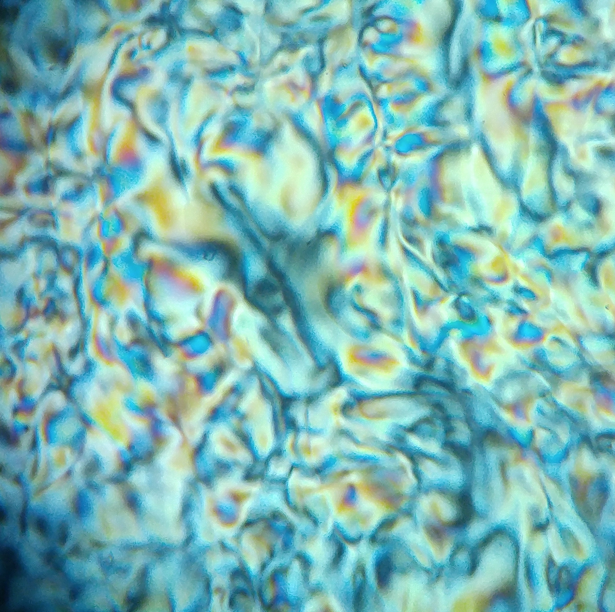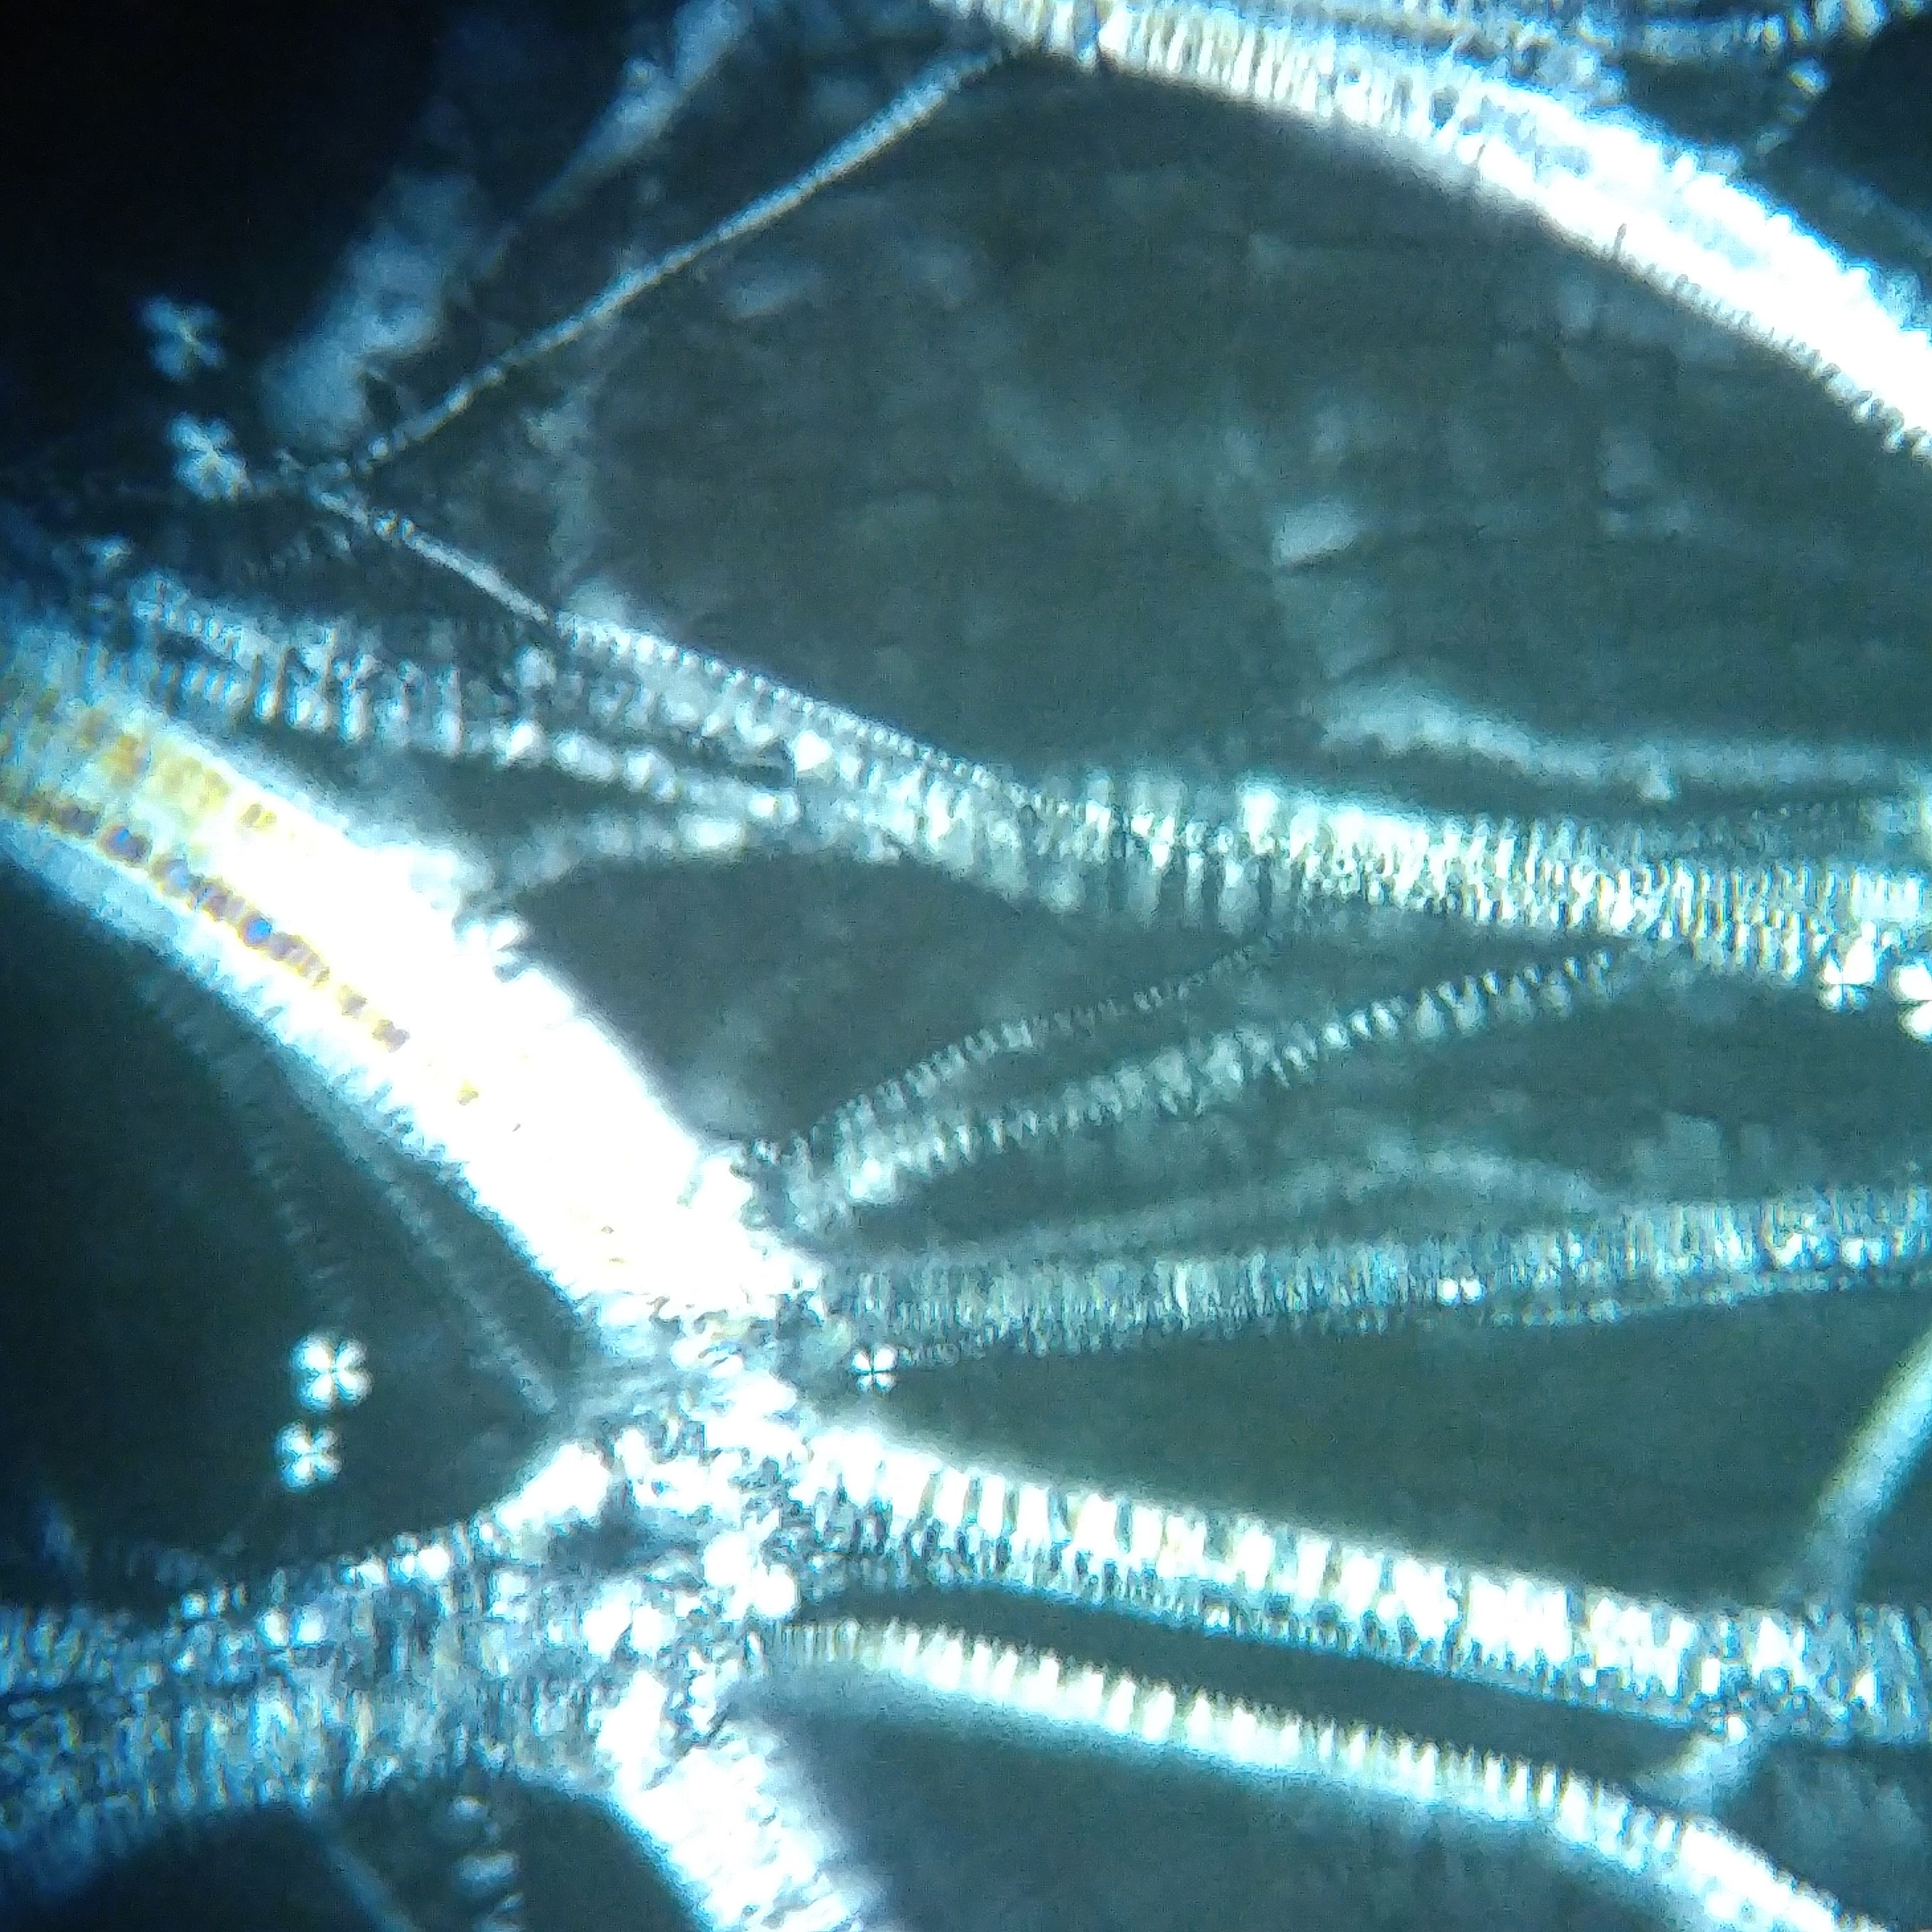

(a) 4% Phospholipid (b) 17% Phospholipid

Figure 2: Polarized light microscopy pictures of membrane mimetics at different phospholipid concentration. Both pictures taken at 100x zoom.

23

24

25

26

27

28

29

30

Phospholipid content [%]

16

17

18

19

20

21

22

23

SDS content [%]

Gel

Semi-solid

Nematic

Figure 3: Partial phase diagram of the membrane mimetic when varying SDS and phospholipid content. The selected composition is marked as a green diamond.

15000

10000

5000

0

5000

10000

15000

Frequency [Hz]

1

0

1

2

3

4

5

6

7

8

Relative intensity

1

e

8

Figure 4: 2H-NMR spectrum of membrane mimetic enriched with SDS-d25. Central peak (not shown completely) belongs to HDO present in the sample, while the rest of the signals are split SDS-d25 signals which were used as reference to calibrate a computational model.

1

2

3

4

5

6

7

8

9

10

11

12

Carbon number

10000

20000

30000

40000

50000

60000

Quadrupolar splitting[Hz]

Experimental

CHARMM36

Berger/B3LYP

Berger/Gromos53A6

Gromos53A6/B3LYP

Gromos53A6

Figure 5: Quadrupolar splittings of SDS-d25 from a 2H-NMR. Comparison between experimental results and predicted by molecular dynamics employing different force-fields

1

2

3

4

5

6

7

8

9

10

11

12

Carbon number

5000

10000

15000

20000

25000

Quadrupolar splitting[Hz]

Experimental

Symmetric thermostat

Asymmetric thermostat

Figure 6: Quadrupolar splittings of SDS-d25 from a 2H-NMR. Comparison between experimental results and predicted by molecular dynamics with symmetric and asymmetric thermostat

4

3

2

1

0

1

2

3

4

Distance from bilayer center [nm]

2.0

1.5

1.0

0.5

0.0

0.5

1.0

1.5

C

h

a

r

g

e

d

e

n

s

i

t

y

[

*q*

*e*

n

m

3

]

Dodecyl sulphate

Sulphate

Sodium

Figure 7: Charge densities of the simulated membrane mimetic.

0.0

0.2

0.4

0.6

0.8

1.0

0

1

2

Water atoms

Water Oxygen

Water Hydrogen

0.0

2.5

5.0

7.5

Sodium

0.0 0.2 0.4 0.6 0.8 1.0 Radial distance from sulfur in SDS [nm]

Figure 8: Radial density function of water and sodium from sulfur in dodecyl sulphate.

1

2

3

4

5

6

7

8

9

10

11

12

Carbon number

100

0

100

200

300

400

500

600

700

800

Frequency variation [Hz]

Benzocaine

Levodopa

Figure 9: Variation on quadrupolar splittings in 2H-NMR upon adding Benzocaine or Levodopa to a membrane mimetic sample enriched with SDS-d25.

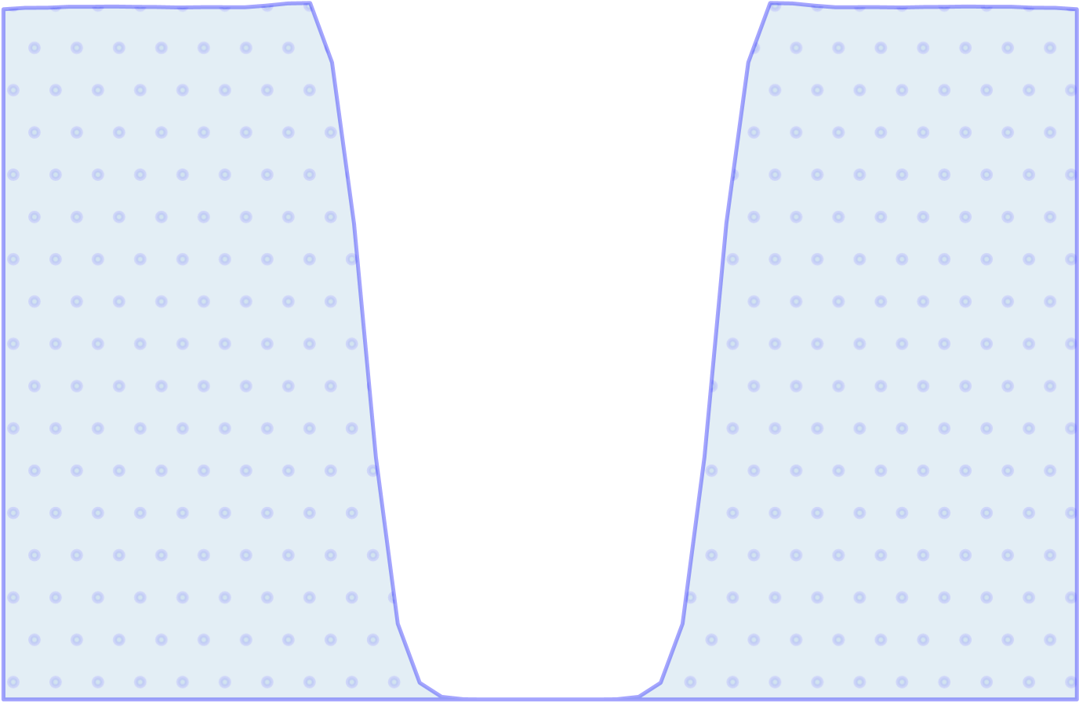

Distance from bilayer center [nm]

0

20

40

60

80

100

A

t

o

m

i

c

d

e

n

s

i

t

y

[

n

m

3

]

6

4

2

0

2

4

6

25

20

15

10

5

0

Potential of mean force [kJ/mol]

A=27.1kJ/mol

A*=11.2kJ/mol

Figure 10: Mean force potential profile for the process of Benzocaine translocating through a membrane mimetic. The blue dotted area represents the water particle density, while the smooth orange area represents the lipid particle density in the simulation.

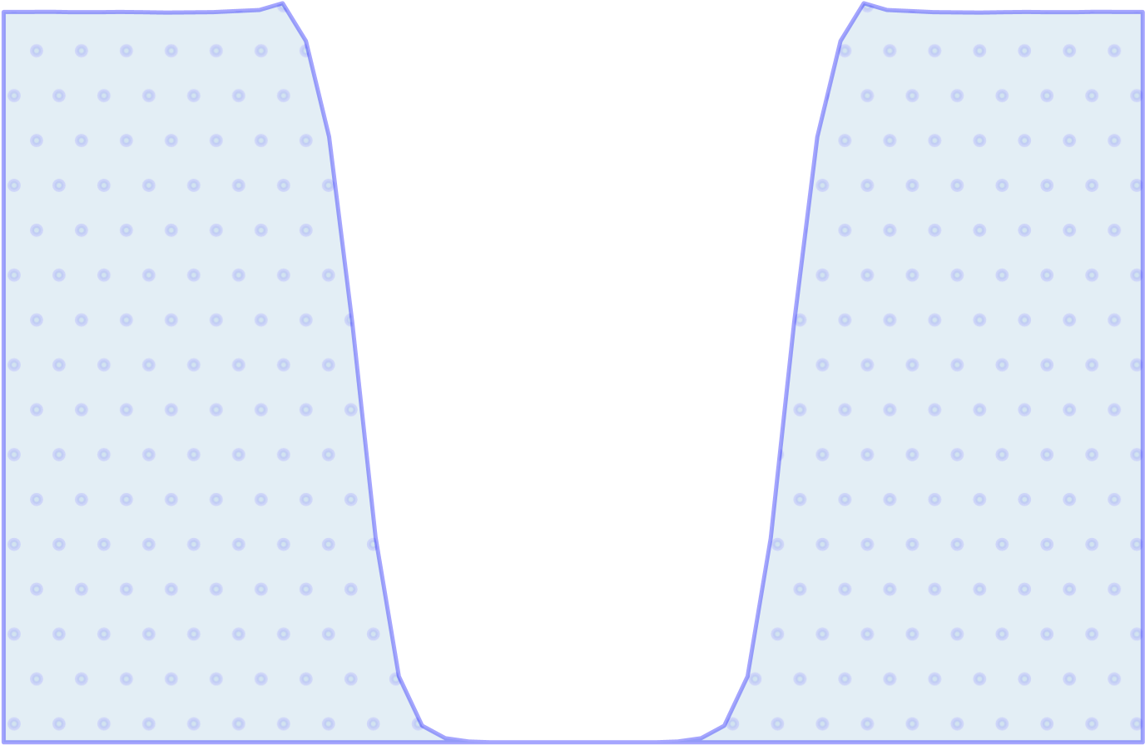

Distance from bilayer center [nm]

0

20

40

60

80

100

A

t

o

m

i

c

d

e

n

s

i

t

y

[

n

m

3

]

4

2

0

2

4

0

20

40

60

80

Potential of mean force [kJ/mol]

A*=102.4kJ/mol

Figure 11: Mean force potential profile for the process of Levodopa translocating through a membrane mimetic. The blue dotted area represents the water particle density, while the smooth orange area represents the lipid particle density in the simulation.

1. E-mail address:diego.munoz.g@ug.uchile.cl

   *Preprint submitted to Elsevier May 25, 2020*
2. 1,2-dimyristoyl-*sn*-glycero-3-phosphocholine
3. 3-(cholamidopropyl)dymethylammonio-2-hydroxy-1-propanesulfonate
4. 1,2-dihexanoyl-*sn*-glycero-3-phosphocholine
5. 1-palmitoyl-2-linoleoyl-*sn*-glycero-3-phosphocholine e1,2-dilinoleoyl-*sn*-glycero-3-phosphocholine
6. 1,2-dilinoleoyl-*sn*-glycero-3-phosphoethanolamine g1,2-dioleoyl-sn-glycero-3-phosphoethanolamine